**Week 6 Coding Assessment**

**File Path**

\Week6CodingAssesment\backend\DeptApi

**To add migration**

-dotnet ef migrations add Initial

**To update the database**

-dotnet ef database update

**To build**

-dotnet run

**Listening on Port**

http://localhost:5244

**Credentials**

Username - admin

Password - Admin@1234

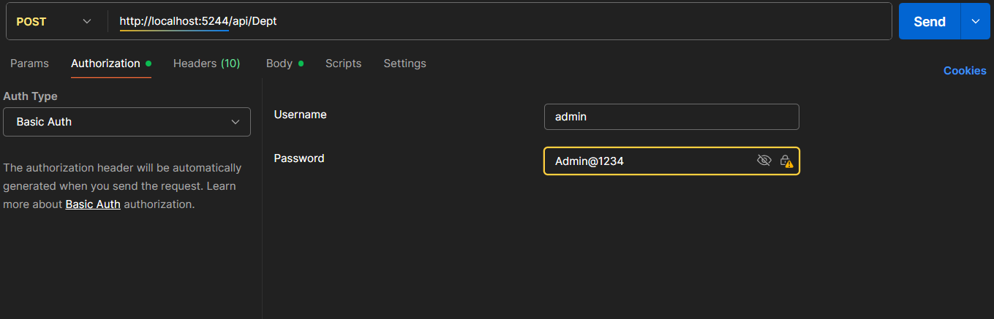

**Postman**

**To get all the Departments**

GET <http://localhost:5244/api/Dept>

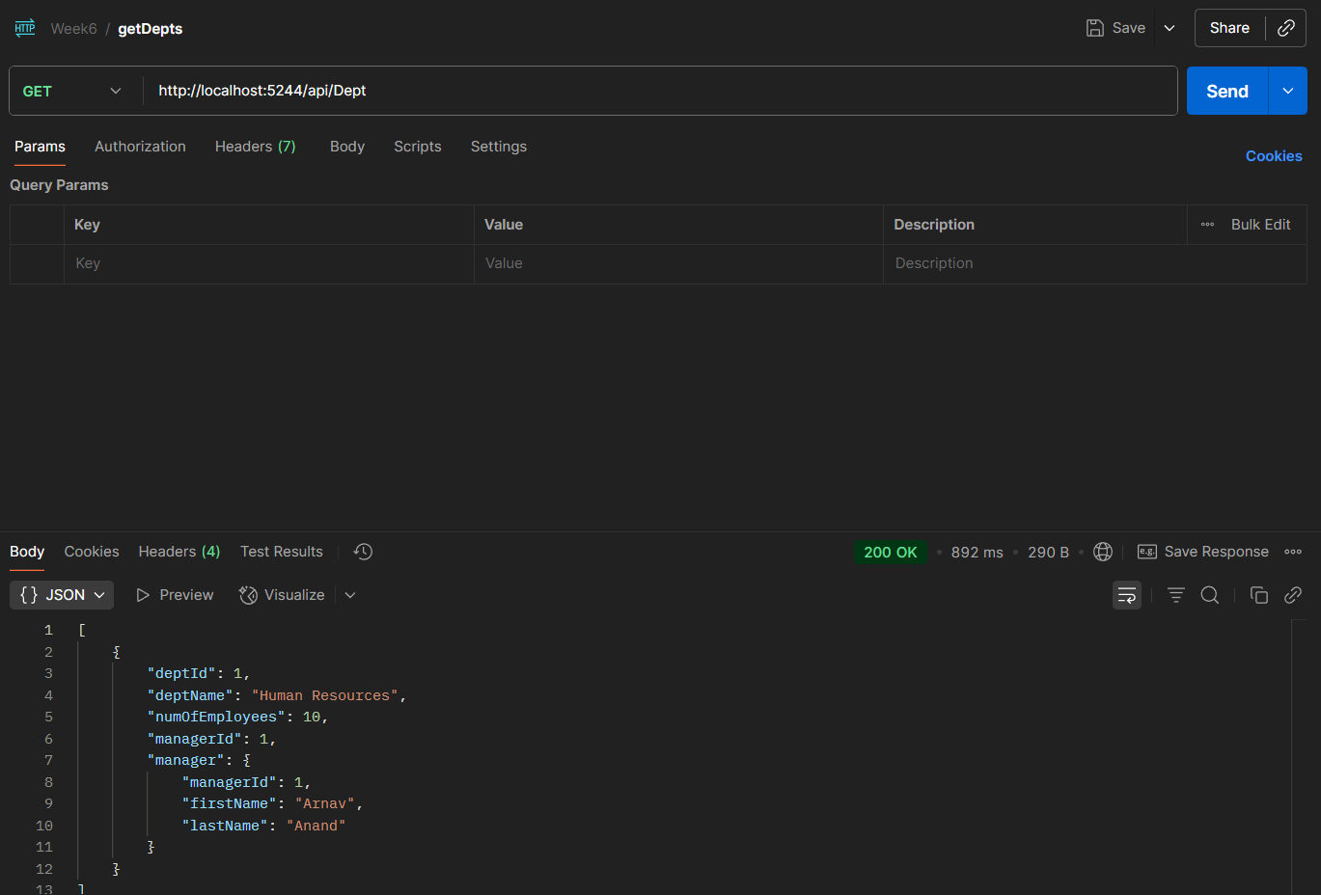

**To get all the Managers**

GET <http://localhost:5244/api/Manager>

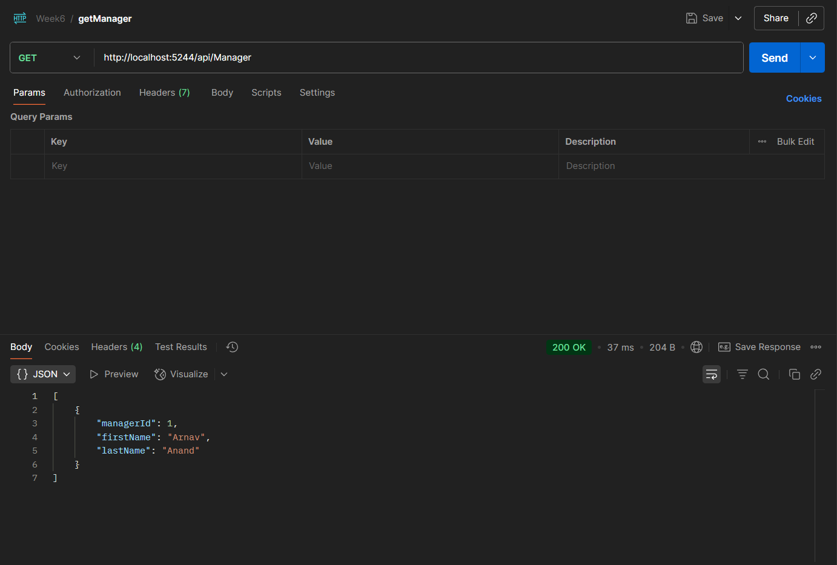

**Adding Manager**

POST <http://localhost:5244/api/Manager>

**Adding Department without Authentication**

POST <http://localhost:5244/api/Dept>

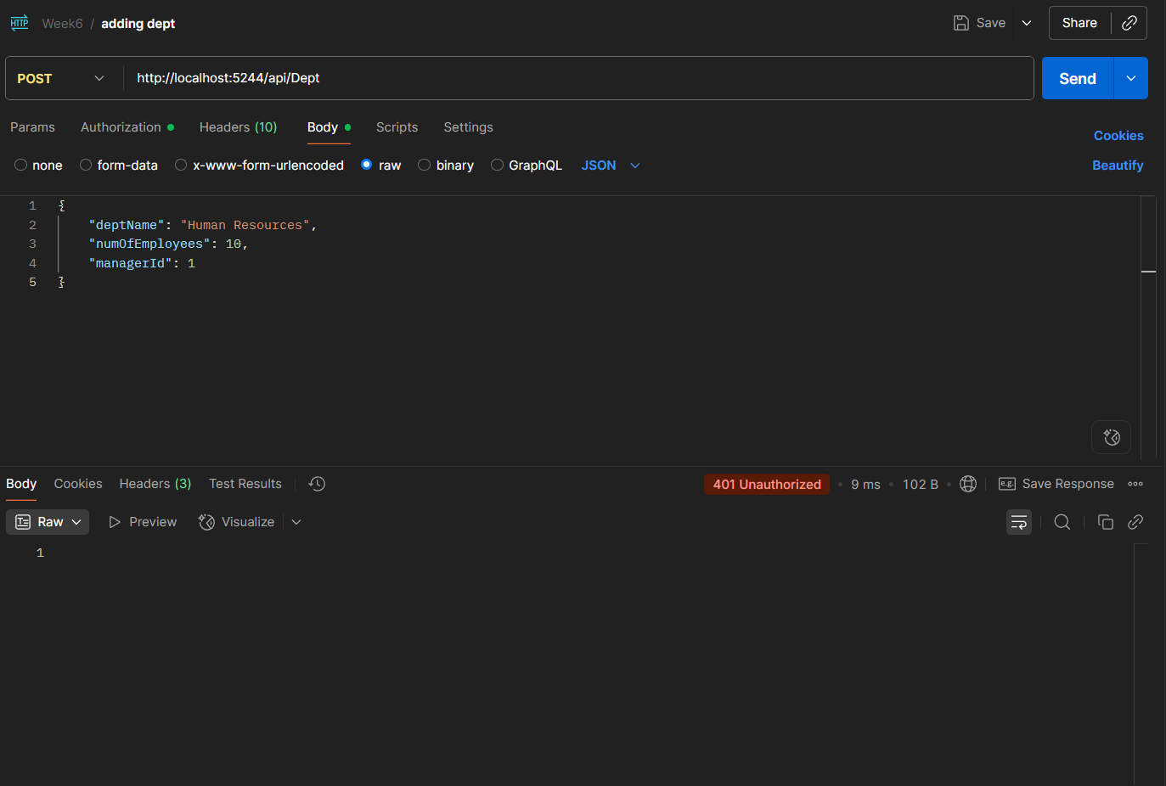

**Adding Department After Authentication**

**POST** <http://localhost:5244/api/Manager>

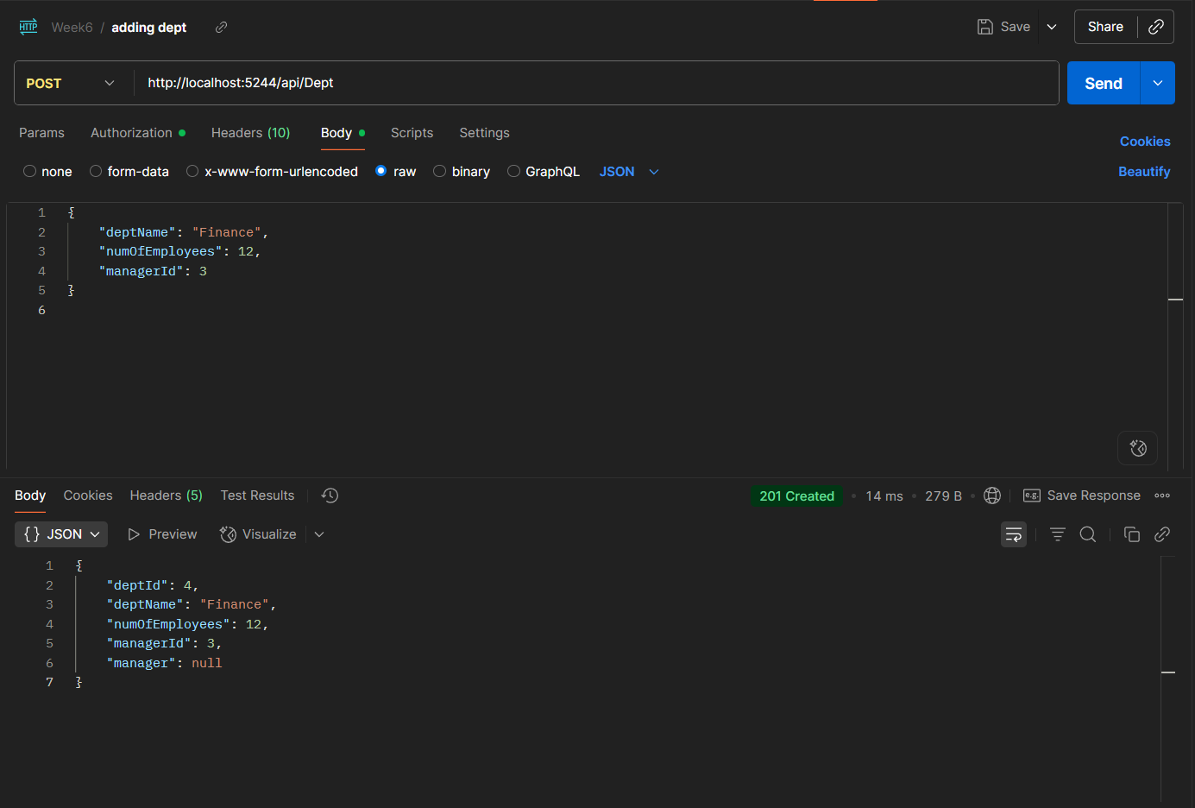

**Getting all the Departments**

After adding a new Department

